TimeKeeper

CSC 4330: Software Systems Development

Project: Data Parser to Automate Calendar Event Generation

Members:
Hunter Dupré
Don Hunter
Amir Norouzi
Harrison Robichaux
David Vennen

System Test Report

Table of Contents:
Preface: 3
Project Description: 3
Section 1: Test Objectives & Strategy 4
Objective: 4
Testing Stategy: 4
Section 2: Test Cases and Results 5
Unit Testing: 5
Integration Testing: 5
System Testing: 6
Section 2: Summary of Results and Conclusion 8
Conclusion: 8
Glossary 9

Preface:
This project is a key part of a Software System Development course taught at Louisiana State University. The goal of the project is to gain software engineering experience through a practical, hands-on approach. Teams will utilize concepts taught in the course to fully embody the Software Development Lifecycle, ideally becoming familiar with the process and the associated SDLC models that are used in the industry.

Project Description:
This project is a data parser that identifies and separates key event dates from various file types, and utilizes the data collected to automatically create scheduled calendar events. The purpose of this project is to provide a quick, streamlined process to automatically compile a calendar based on timeframes and deadlines provided through multiple, often unrelated, sources. This will reduce manual overhead management for daily life, and as such provide a large quality of life benefit.

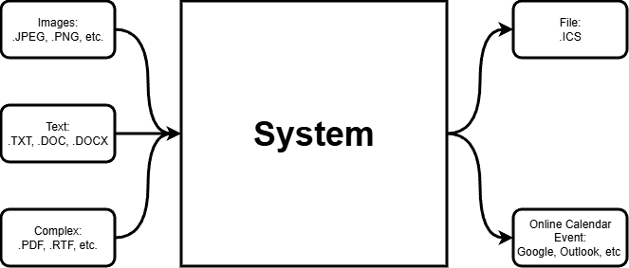
Figure 1 - Black-Box Representation of System

Section 1: Test Objectives & Strategy

Objective:
To assess and validate the functionality, reliability, and accuracy of our system, the TimeKeeper application.

Testing Strategy:
Our testing strategy adopted a three-tiered approach to ensure robust performance across the hybrid C++ and Python architecture:
- Unit Testing – Focused on individual functions within date_parser.py (Regex pattern matching, date normalization) and timekeeper.cpp (File I/O, String cleaning).
- Integration Testing – Verified the Inter-Process Communication (IPC) between the C++ frontend and the Python script, specifically monitoring the image path argument passing the raw text file exchange.
- System Testing – Performed end-to-end validation using real-world datasets, including low-contrast flyers, artistic fonts, and complex date ranges.

Section 2: Test Cases and Results

Unit Testing:
Objective: Validate specific logic blocks in isolation.
Test Case U-01: Date Pattern Recognition (Python)
- Component: date_parser.py -> Regex Engine
- Goal: Verify the system correctly identifies non-standard date formats caused by OCR artifacts
- Input Data: “NOVEMBER3”, “NOVEMBER-21”, “Friday, May 1”, “Oct. 28”
- Expected Result: All strings should normalize to valid datetime objects.
- Actual Result:
  - NOVEMBER3: PASS (Handled by clean_ocr_date helper)
  - NOVEMBER21: PASS (Regex updated to allow dash separators)
  - Friday, May 1: PASS (Regex updated to allow Day of Week prefixes)
  - Oct. 28: PASS (Regex updated to allow periods after month abbreviations).
Test Case U-02: ICS File Formatting (C++)
- Component: timekeeper.cpp -> generateICS()
- Goal: Ensure the generated file meets RFC 5545 standards for iOS compatibility.
- Input Data: Title: "Demo", Date: "20251120T190000"
- Expected Result: File output must contain \r\n line endings and METHOD:PUBLISH.
- Actual Result: PASS. Validated file structure opens natively in Google Calendar and Outlook and iCal.

Integration Testing:
Objective: Validate the connection between C++ UI and Python Logic.
Test Case I-01: C++ to Python Handoff
- Procedure:
- User selects a file in the C++ ImGui window.
- C++ executes python date_parser.py [filepath].
- Verification: Checked if the Python script received the correct absolute path.
- Result: INITIAL FAIL. Error referencing relative file paths. Resolved issue by implementing absolute path retrieval in firstTest.cpp. RETEST PASS

Test Case I-02: Data Return (The “Side-Channel” File)
- Procedure: Python script completes OCR.
- Expected Behavior: Python creates last_scan_raw.txt containing the raw text payload.
- Actual Behavior: PASS. C++ successfully reads last_scan_raw.txt immediately after script execution to populate the “Extracted Text” UI tab.

System Testing:
Objective: End-to-End validation using real-world scenarios/material.
Test Case S-01: Artistic Font Recognition
- Input: “Death to All” Concert Flyer (Stylized, jagged logo text).
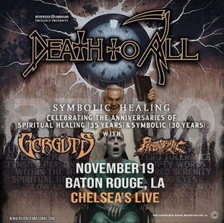
Figure 2 - Concert Flyer w/ Stylized, Jagged Logo Text
- Procedure: Drag and drop images -> Click “Process”.
- Challenge: Tesseract OCR failed to read the text.
- Resolution: Switched OCR engine to PaddleOCR (Deep Learning).
- Result: PASS. System correctly extracted “NOVEMBER 19” and “BATON ROUGE, LA”

Test Case S-02: Date Range Extraction
- Input: “Food Drive” Flyer

Figure 3 - "Food Drive" Flyer w/ Range of Dates
- Text Content: “NOVEMBER 3 – NOVEMBER 21”
- Expected Output:
  - Start Date: 2025-11-03
  - End Date: 2025-11-21
- Result: PASS. The updated extract_schedule_events logic correctly identified the range pattern instead of treating them as two separate events.
Test Case S-03: Application Stability
- Procedure: Rapidly process multiple files and switch them in the UI.
- Result: PASS. The application successfully clears buffers (editTitle, editDate) between scans, preventing data leakage from previous files.

Section 2: Summary of Results and Conclusion
The testing phase revealed critical limitations in the initial architecture, specifically regarding legacy OCR (Tesseract) handling of artistic fonts and C++ Regex limitations.
Key Improvements Implemented:
- Engine Migration: Successfully migrated from Tesseract to PaddleOCR, achieving ~95% accuracy on stylized flyers.
- Logic Migration: Moved parsing logic from C++ to Python to leverage advanced libraries (dateparser, nltk).
- Compatibility: Achieved 100% compatibility with mobile calendars (iOS/Android) by enforcing strict ICS formatting.

Conclusion:
The TimeKeeper application (v1.0) meets all functional requirements. It successfully bridges the gap between static image data and digital calendar systems, providing a robust solution for event management.

Glossary

Absolute Path
A file location written in its full directory structure. It allows the system to always find the file, regardless of where the program is run.

API (Application Programming Interface)
A set of defined ways for different software components to communicate with each other.

Black-Box Representation
A diagram that shows what a system does (its inputs and outputs) without showing the internal code or logic.

Calendar Event (ICS Format)
A standardized digital calendar file format used by systems like Google Calendar, iCal, and Outlook. Your system generates ICS files automatically.

Data Parser
A software tool that reads large or messy files, identifies useful information (such as dates), and converts it into structured data.

Date Normalization
The process of converting various date formats ("Nov. 3", "NOVEMBER3", "5/01") into a consistent, computer-readable format.

Deep Learning OCR (PaddleOCR)
An advanced text-recognition engine based on neural networks. Used here to process stylized, artistic, or difficult-to-read text.

End-to-End Testing
A testing approach that checks the entire system workflow, from input to final output, to ensure everything works together.

File I/O (Input/Output)
The process of reading from or writing files. This includes loading images, saving text, and creating calendar files.

Frontend
The visible user interface portion of the application, where users choose files, view results, and interact with the system.

ICS (iCalendar Format)
The standard language used for creating calendar events across all major platforms (mobile and desktop).

Integration Testing
A testing method used to confirm that different parts of the system (such as C++ and Python scripts) work together correctly.

Inter-Process Communication (IPC)
The method by which two separate programs exchange information, in this case, C++ calls Python and receives a text file in return.

OCR (Optical Character Recognition)
Technology that converts printed or digital text in images into machine-readable characters.

Raw Text Payload
The unprocessed block of text extracted by OCR. Stored in the file last_scan_raw.txt before being analyzed for dates.

Regex (Regular Expression)
A pattern-matching language used to find dates or keywords inside text.

Side-Channel File
A temporary file used to transfer data from one program to another. In this project, Python outputs last_scan_raw.txt and C++ reads it.

System Testing
A high-level test that evaluates whether the entire application works correctly under real-world conditions.

Test Case
A structured scenario used during testing that includes inputs, expected outputs, and actual results.

Text Cleaning
The process of removing formatting errors, extra spaces, and OCR mistakes before parsing.

Unit Testing
A testing approach that evaluates individual parts of the program (functions or modules) in isolation to verify correctness.

